AWS Youtube Video

Root User is the one who has complete access to all the resources and aws services in a account.

Management Console

IAM – Identity and Access Management

We can create users in IAM

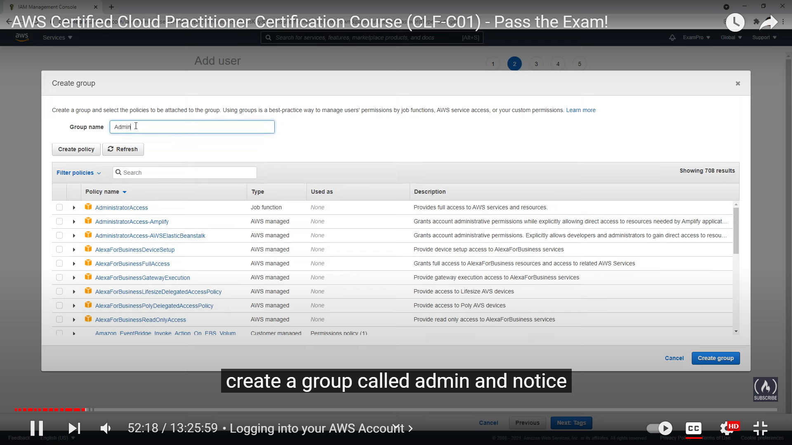

We have to map all the users to a group, If there is no group present, we have to create group. We can create group and map the policy for the group as shown above

There are many policies, but the ones to be noted are:

1. AdministrationAccess
2. PowerUserAccess

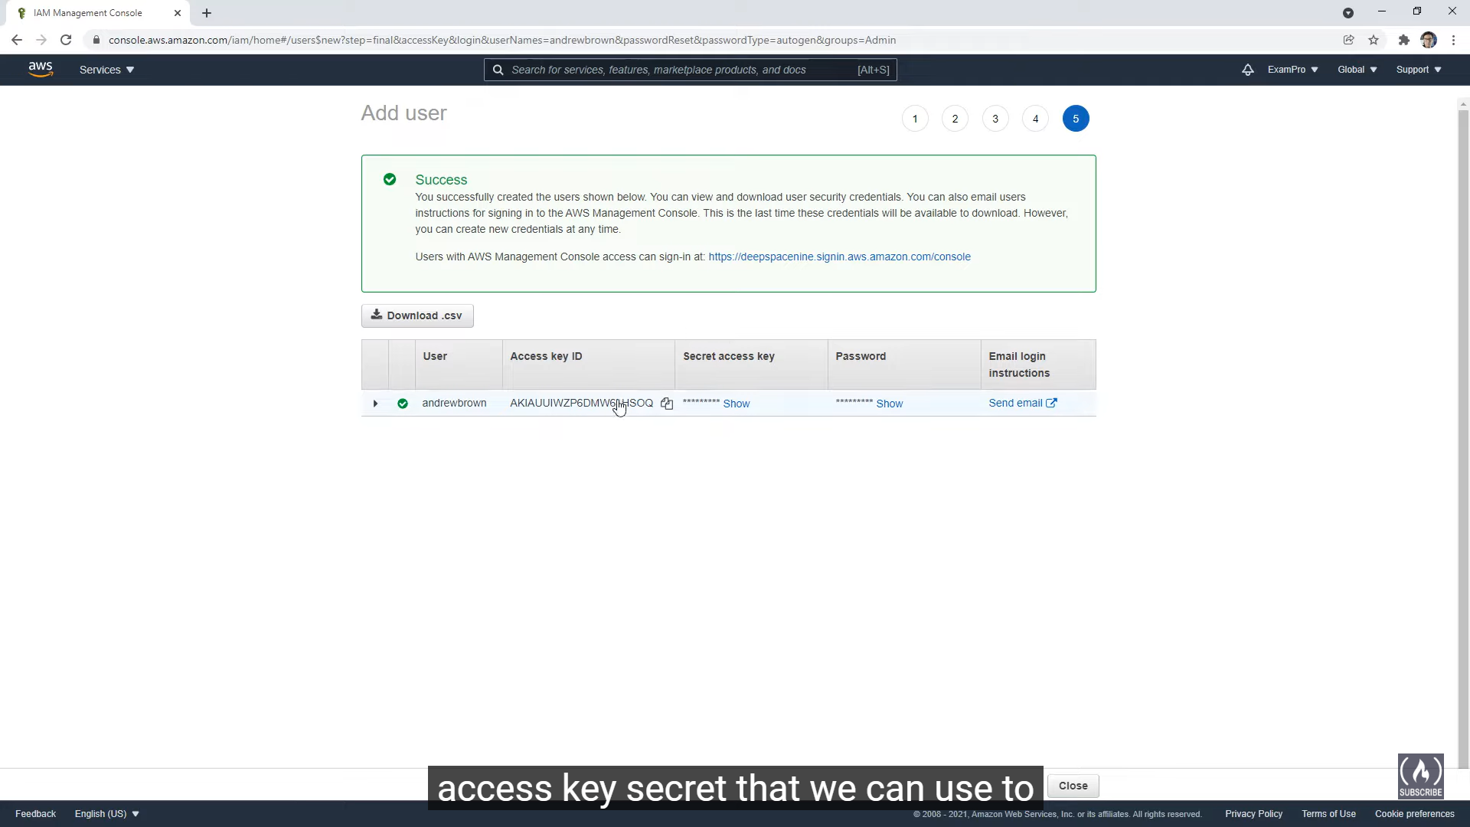

After creating the user, we will get the access Id and access password, by using these two and accountId, we can login

**AWS Regional Selection**

Some of the services are global, some of the services are specific to a region, so we have to select a region.

Us-east-1 is the original or the first region with most of the aws services with most availablility

**AWS Budget Selection**

Go to Budget Dashboard

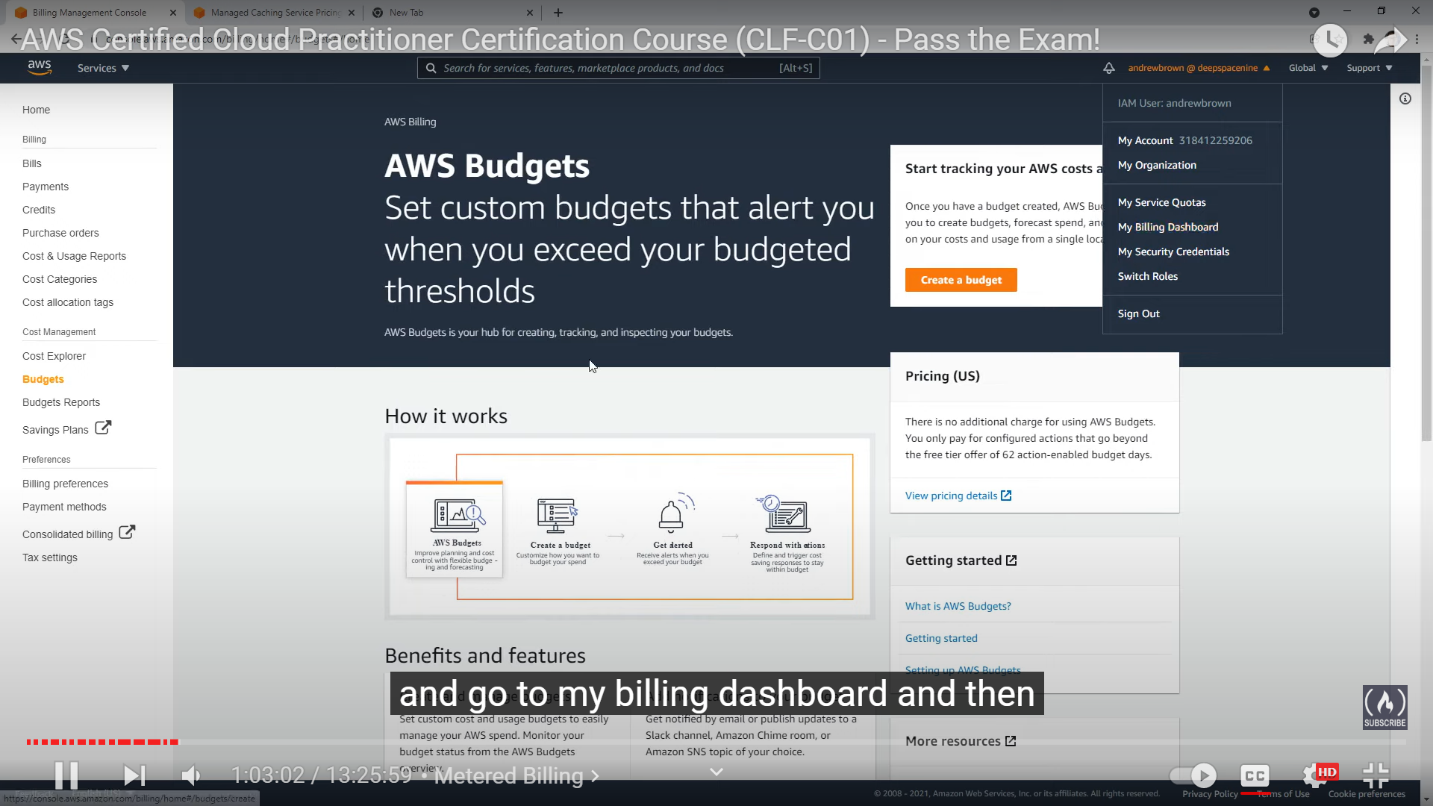

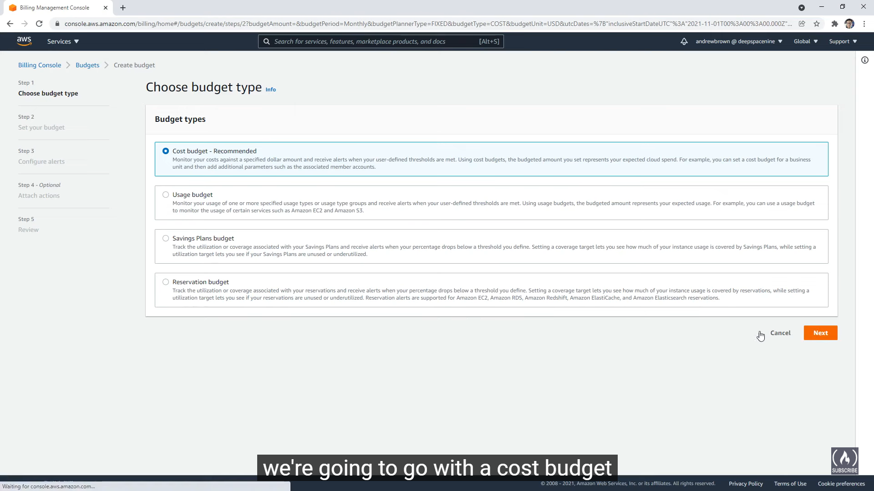

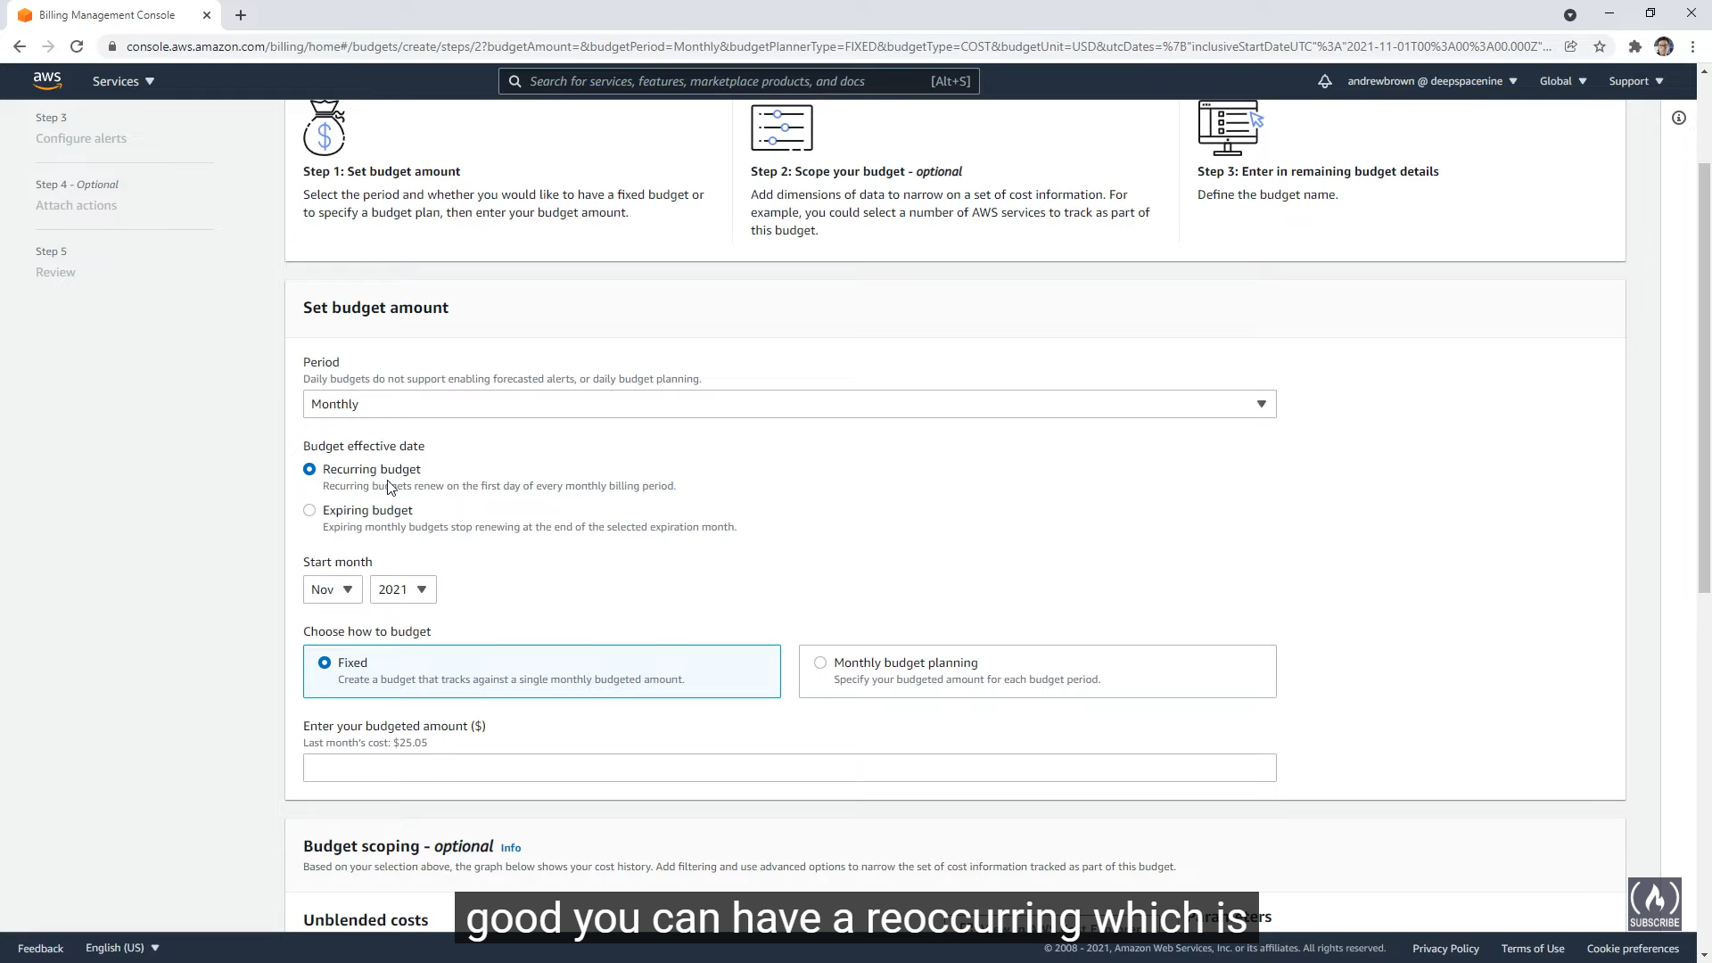

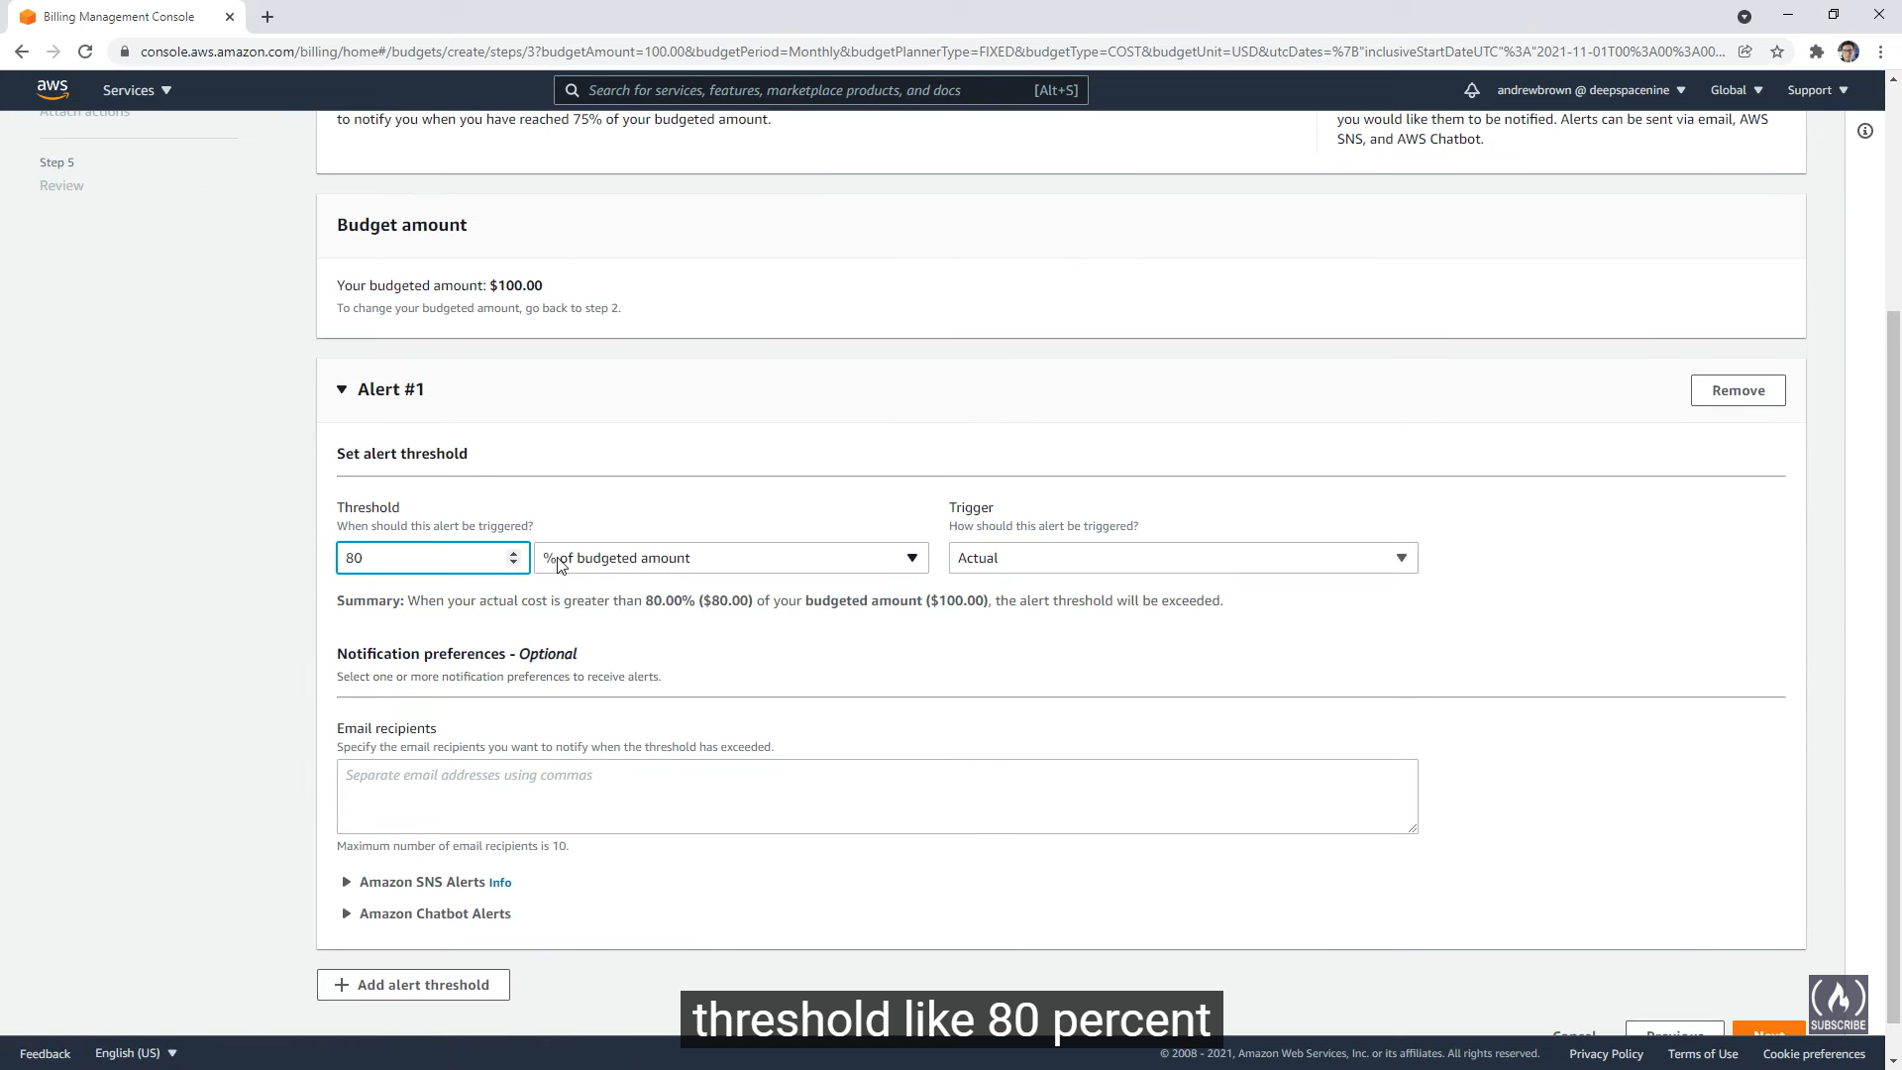

Add alerts as shown above

Amazon SNS – Message to Mobile

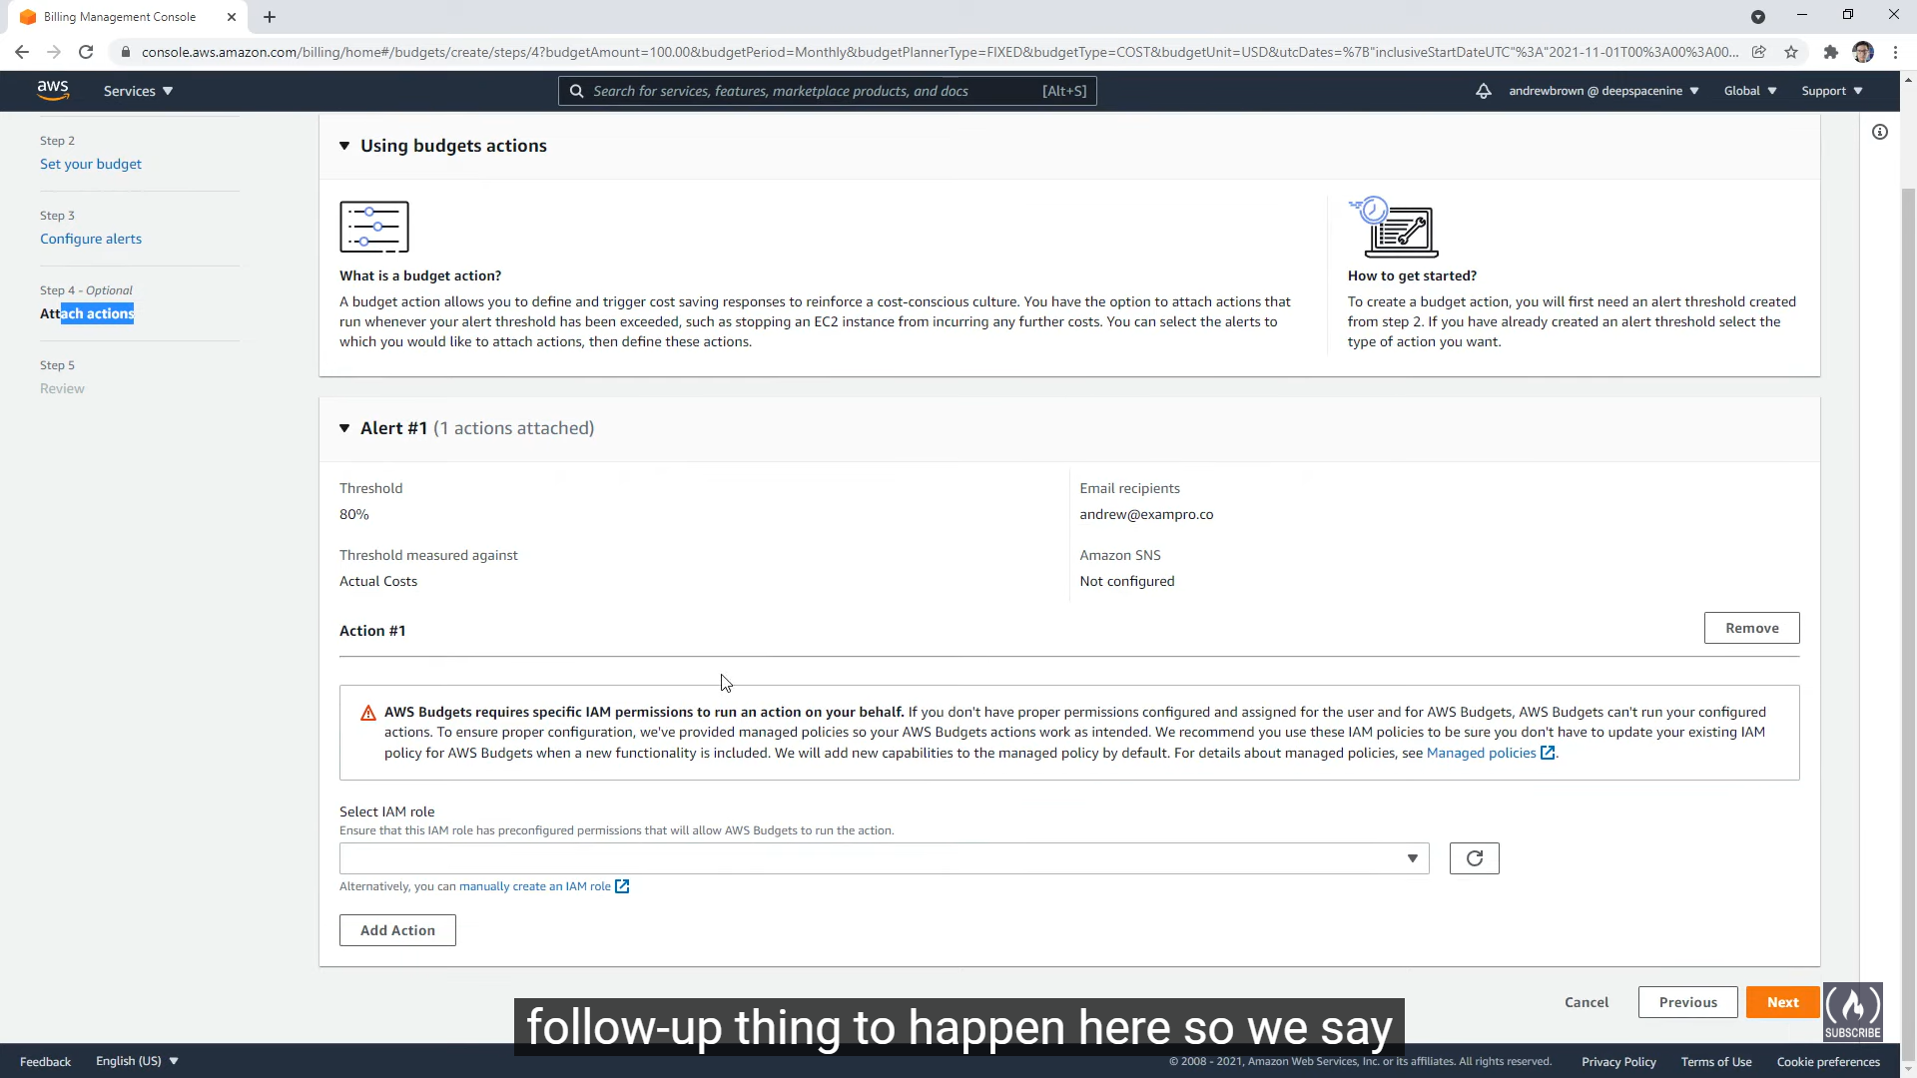

We can add Follow-up Action to happen incase of alert

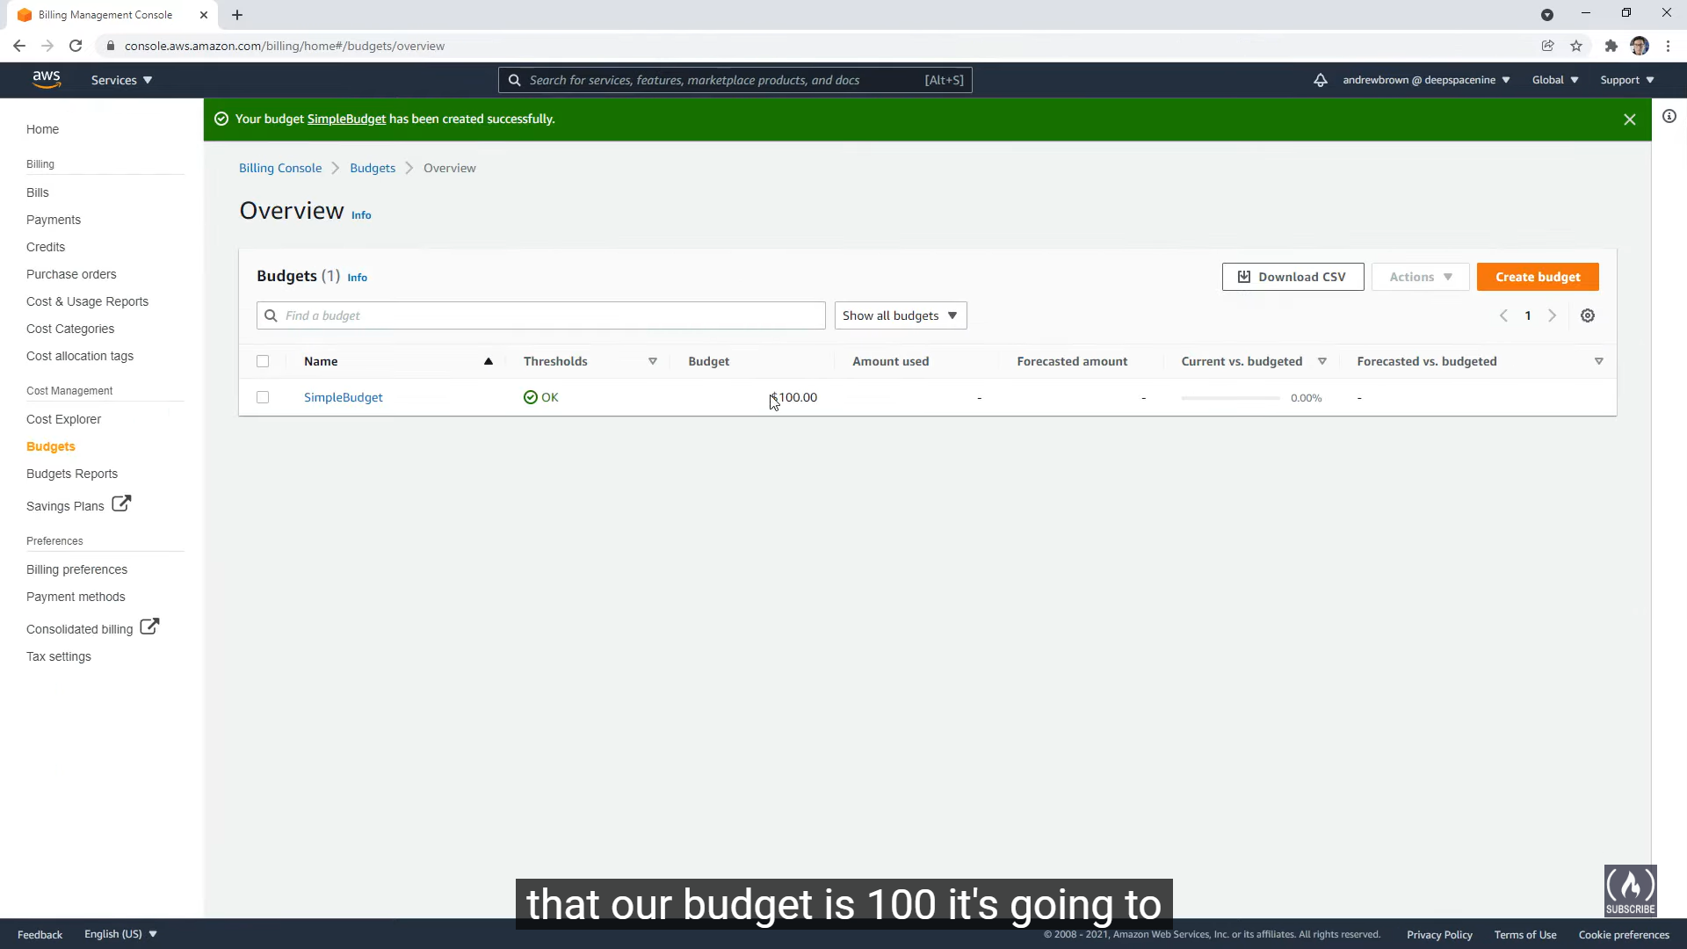

We can see the forecast and budget in the Overview after adding Budget

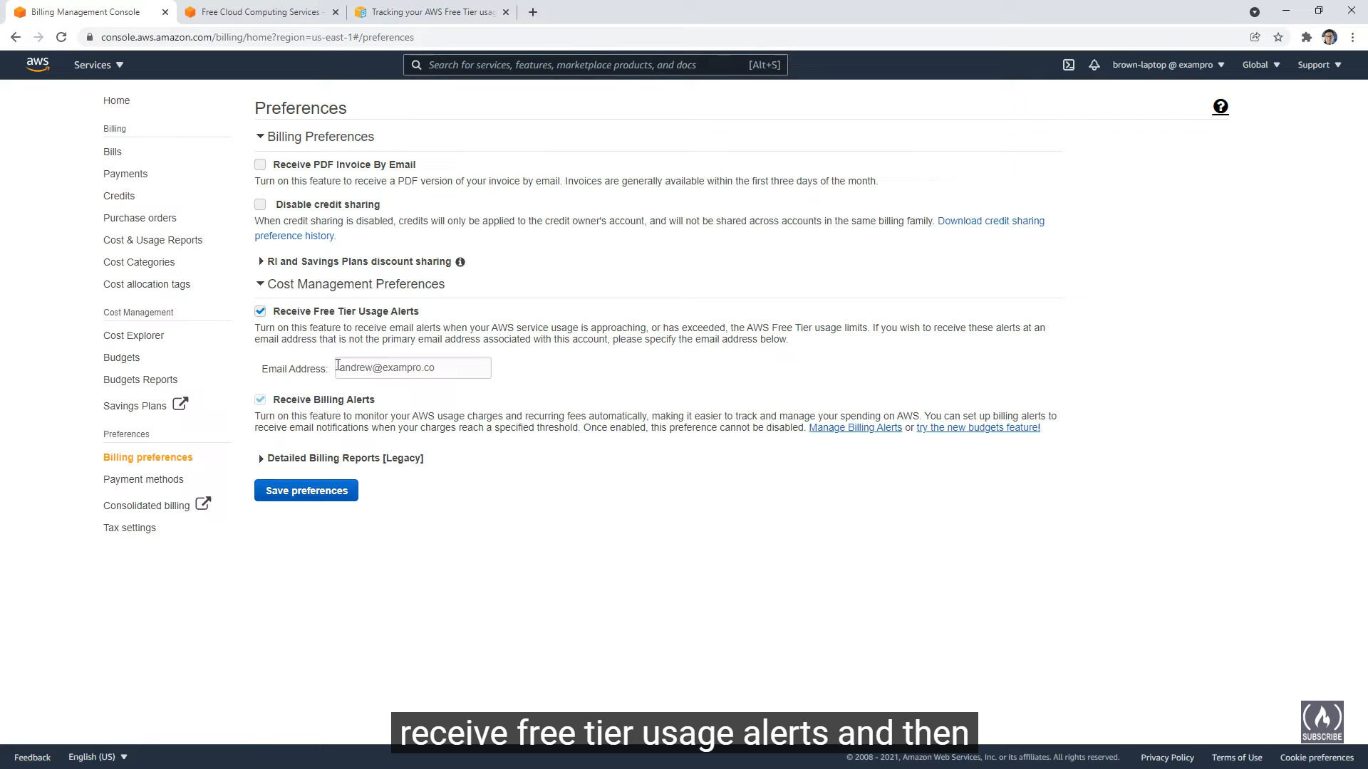

Enable the checkbox, receive free tier usage alerts and receive billing alerts to send mail related to the message related to ending of free tier usage alerts and billing alerts.

**CloudWatch**

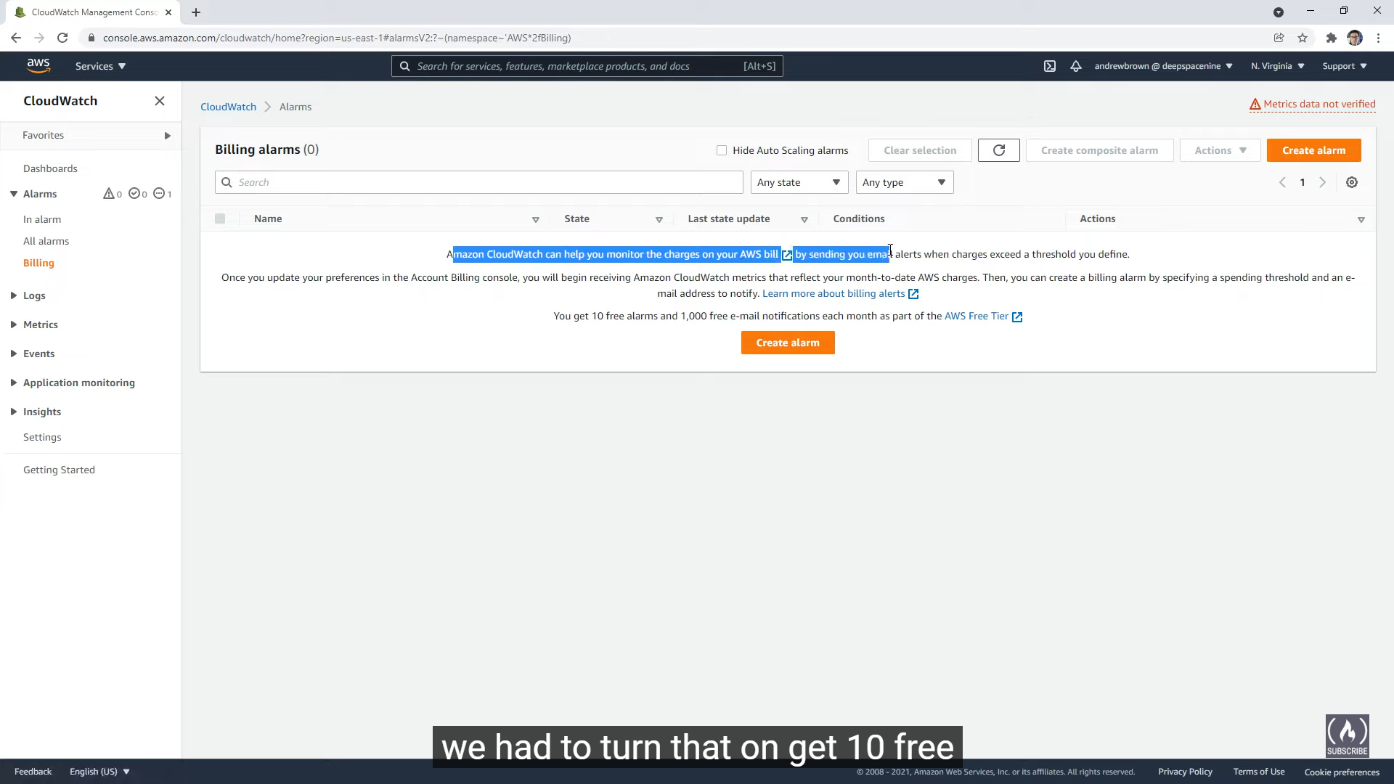

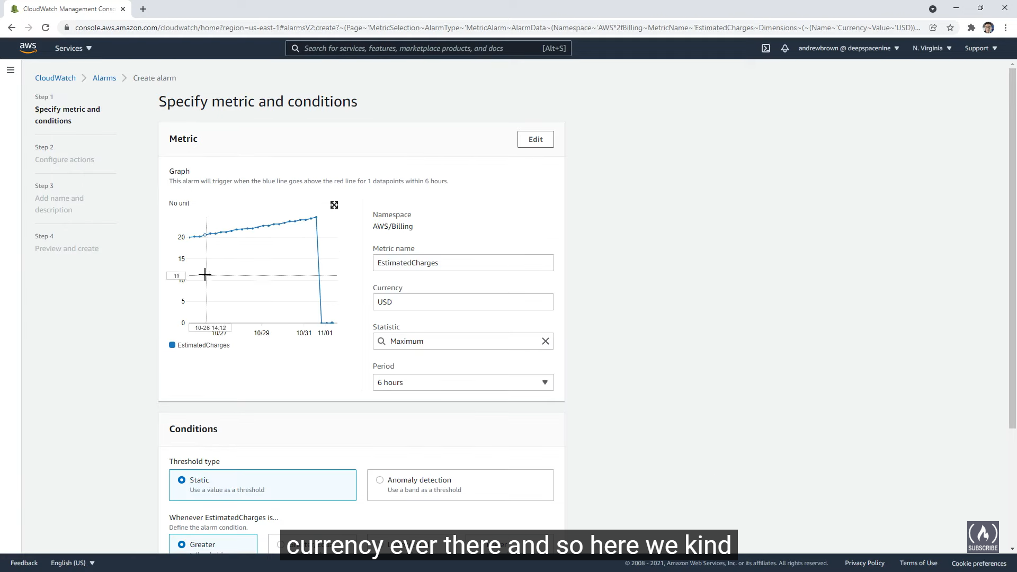

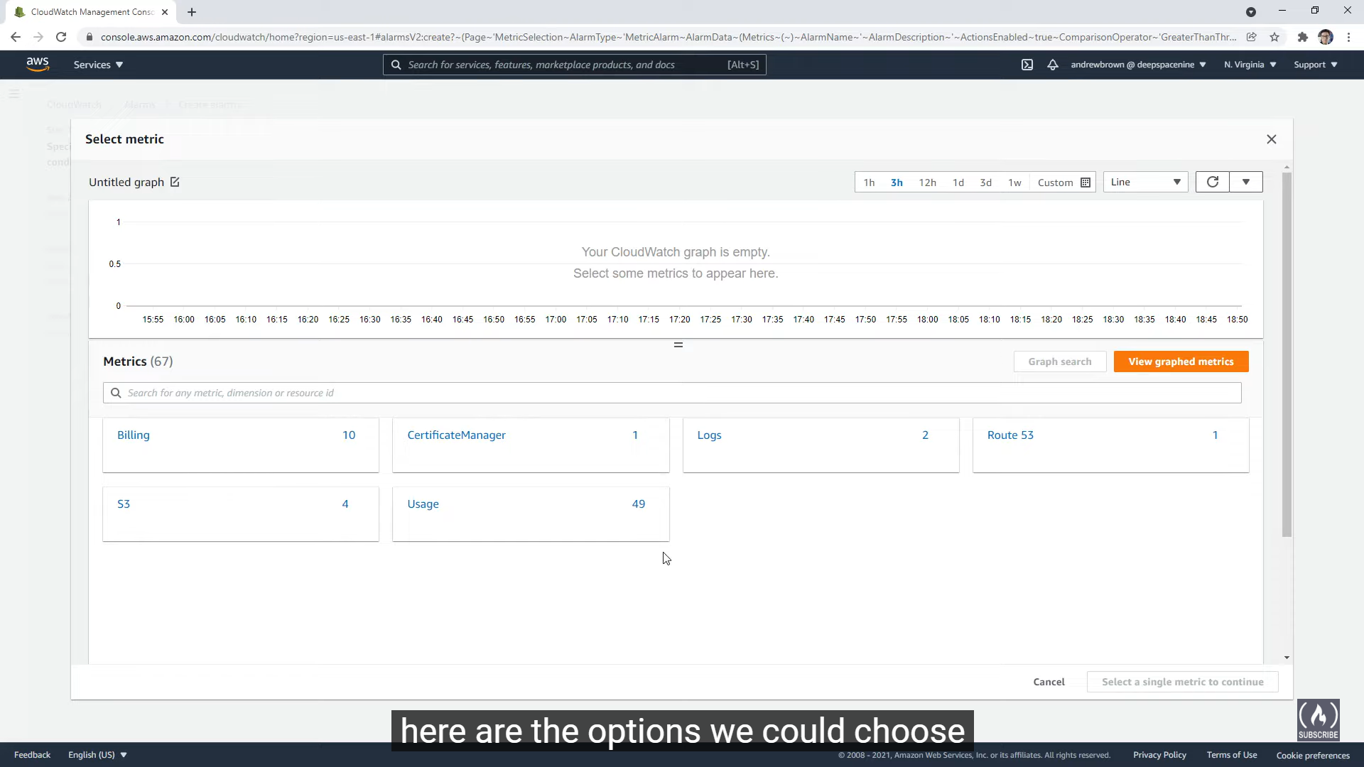

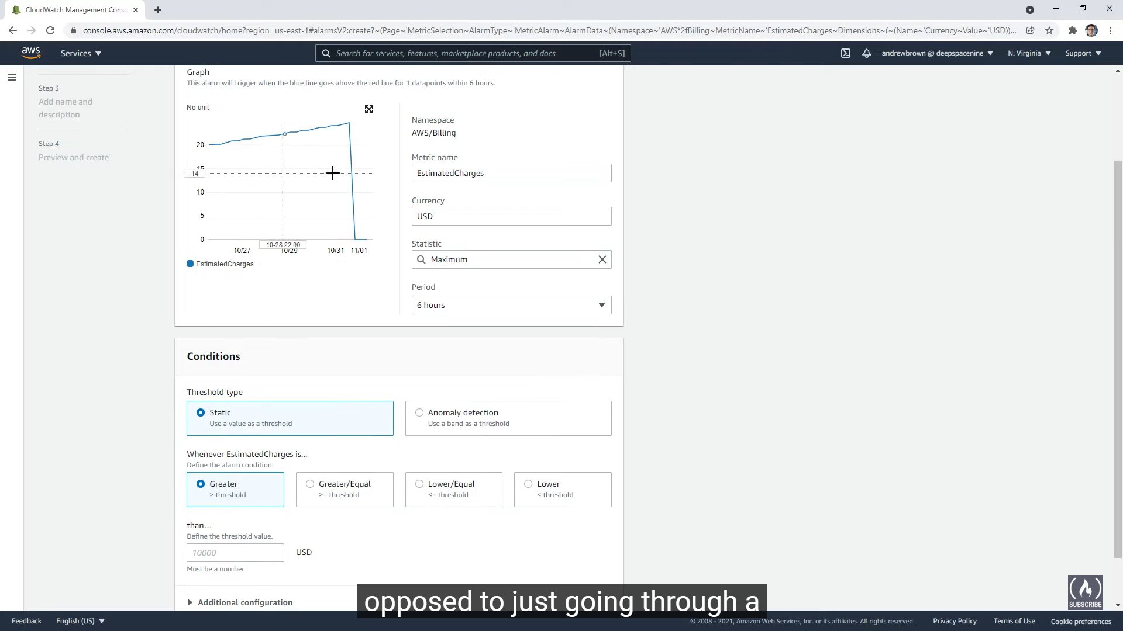

Cloudwatch is more powerful than Budgets, here we can see things like Anomaly detection

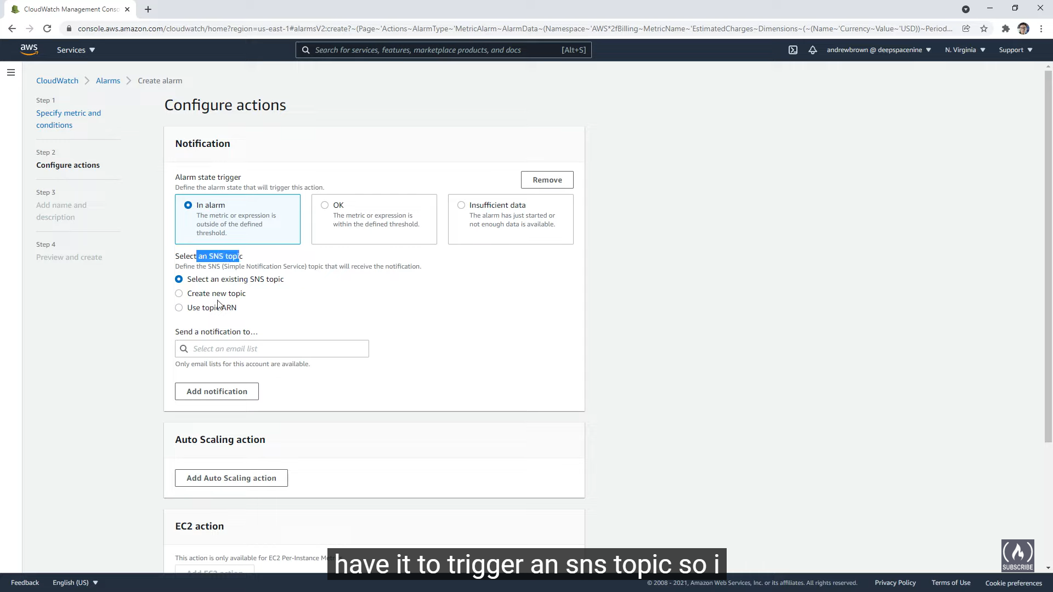

We can select the SNS topic to which the alarm email will be sent

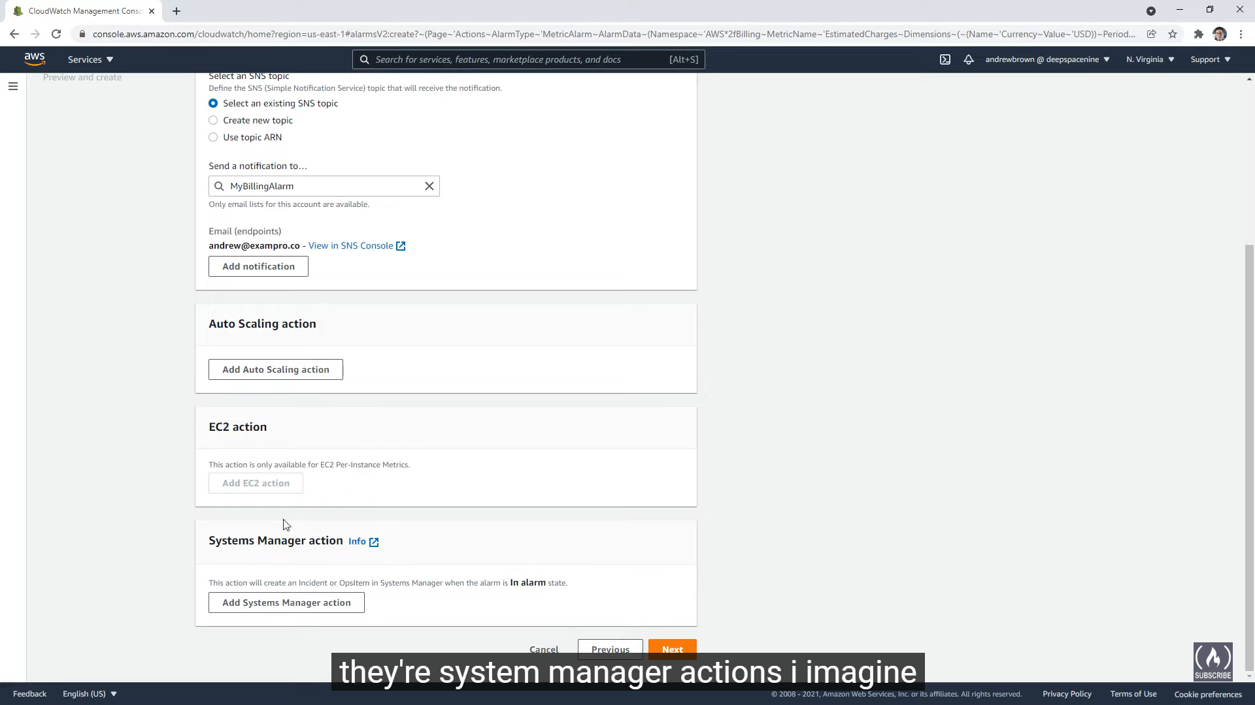

Auto-scaling action can be used to shutdown some servers when there are too many servers created

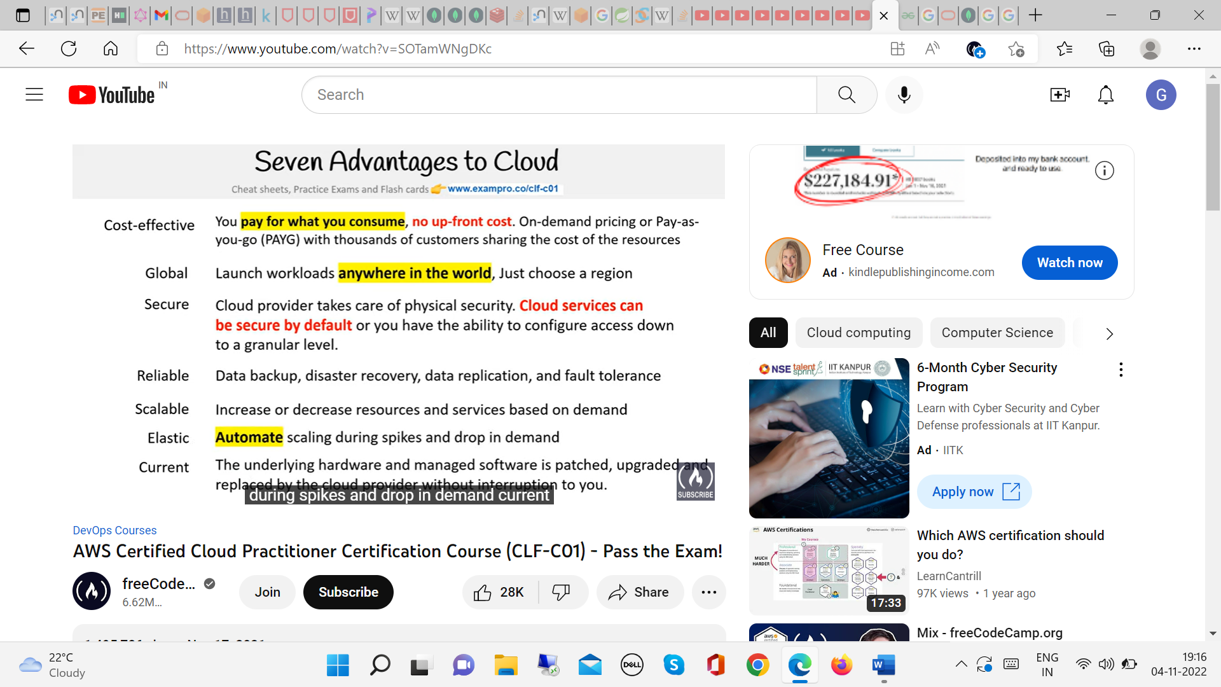

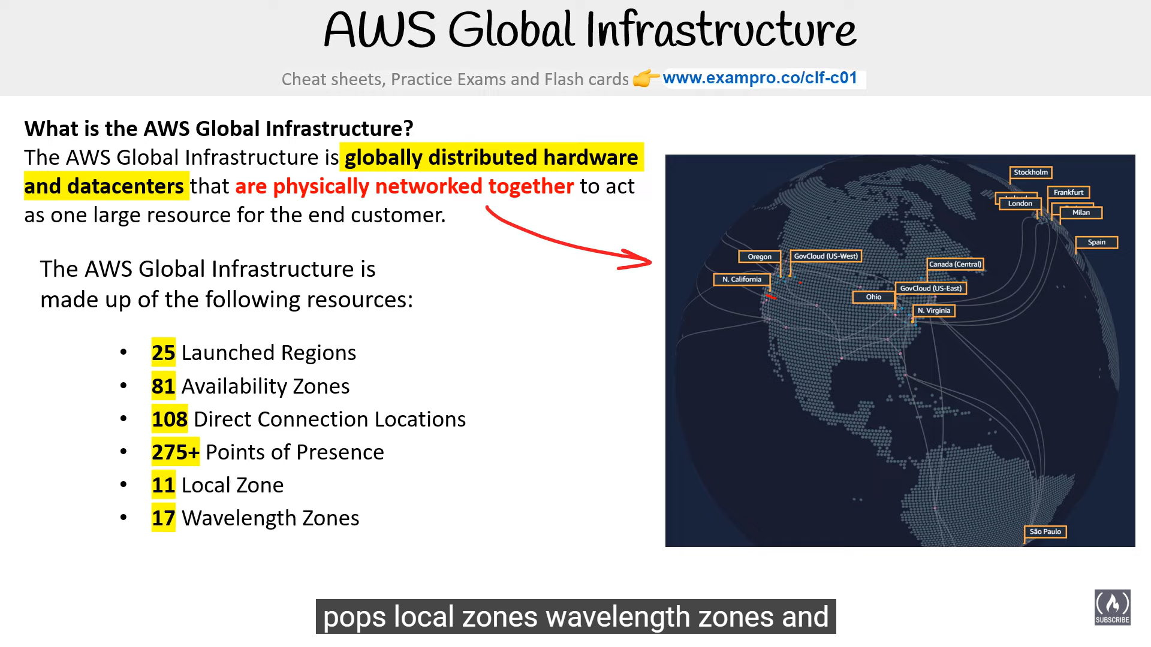

**Example Architecture Flow Diagram**

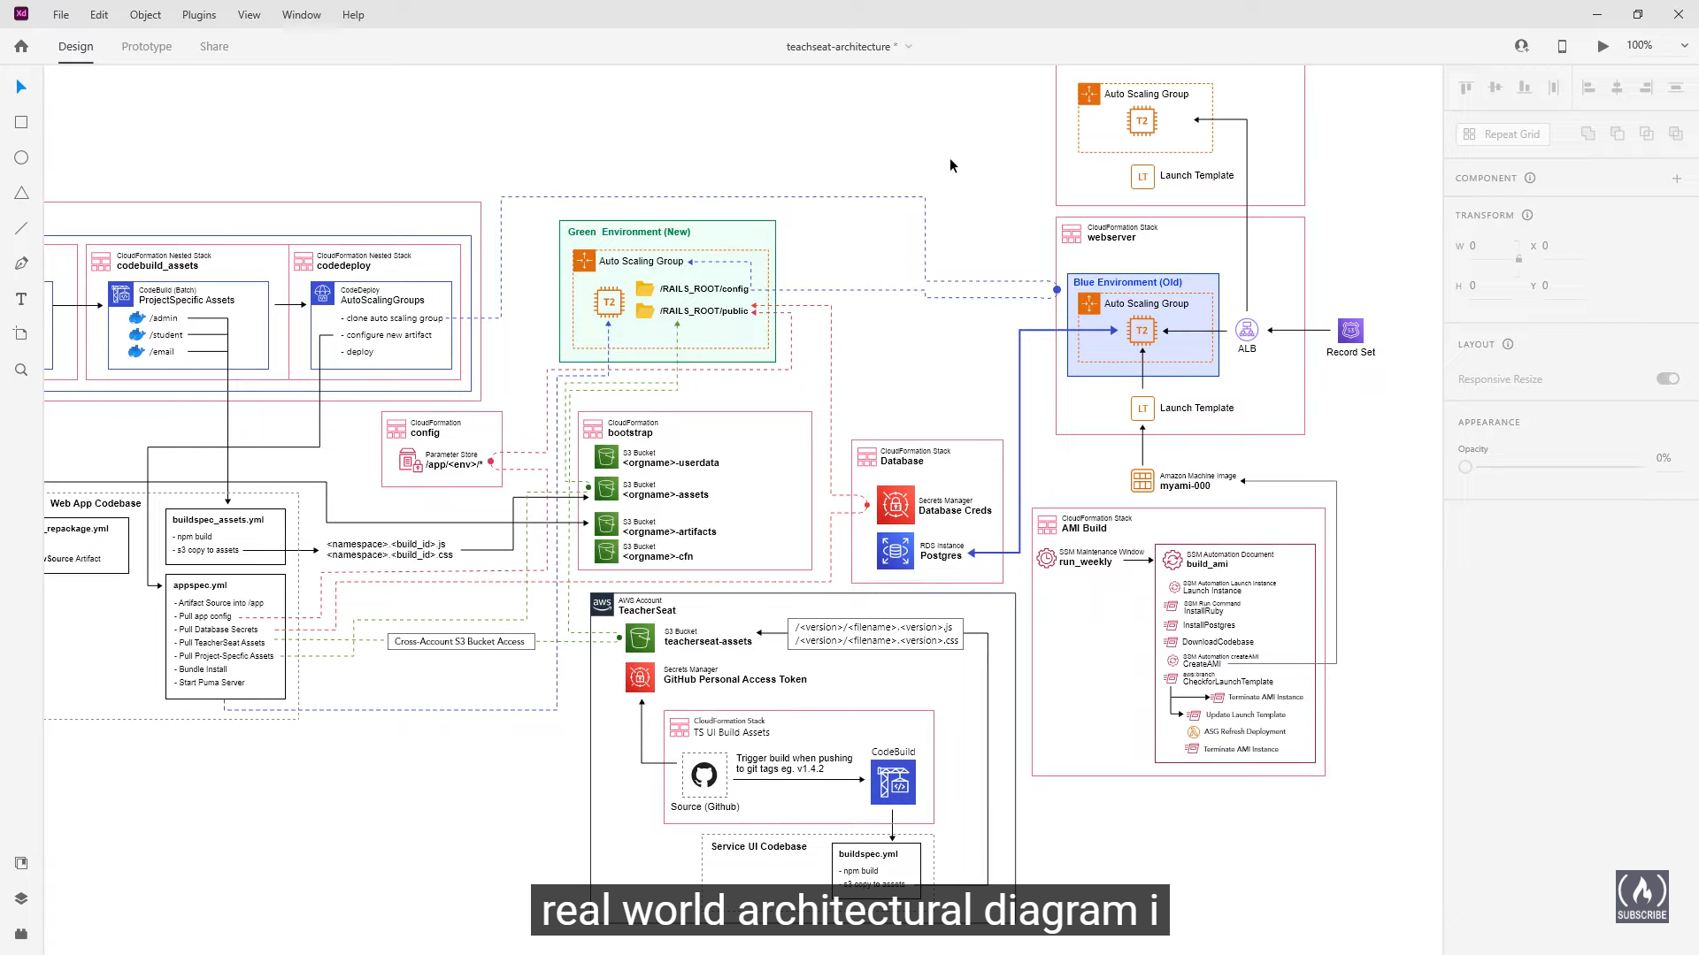

Auto-Scaling group can create an instance automatically when the load increases

**Cloud Formation**

Parameter Store is for storing environment variable

Secrets Manager to store DB credentials

Blue-Green Deploy, Replace the running Blue server with the new Green server after deployment and copy the blue server instance to all the instances

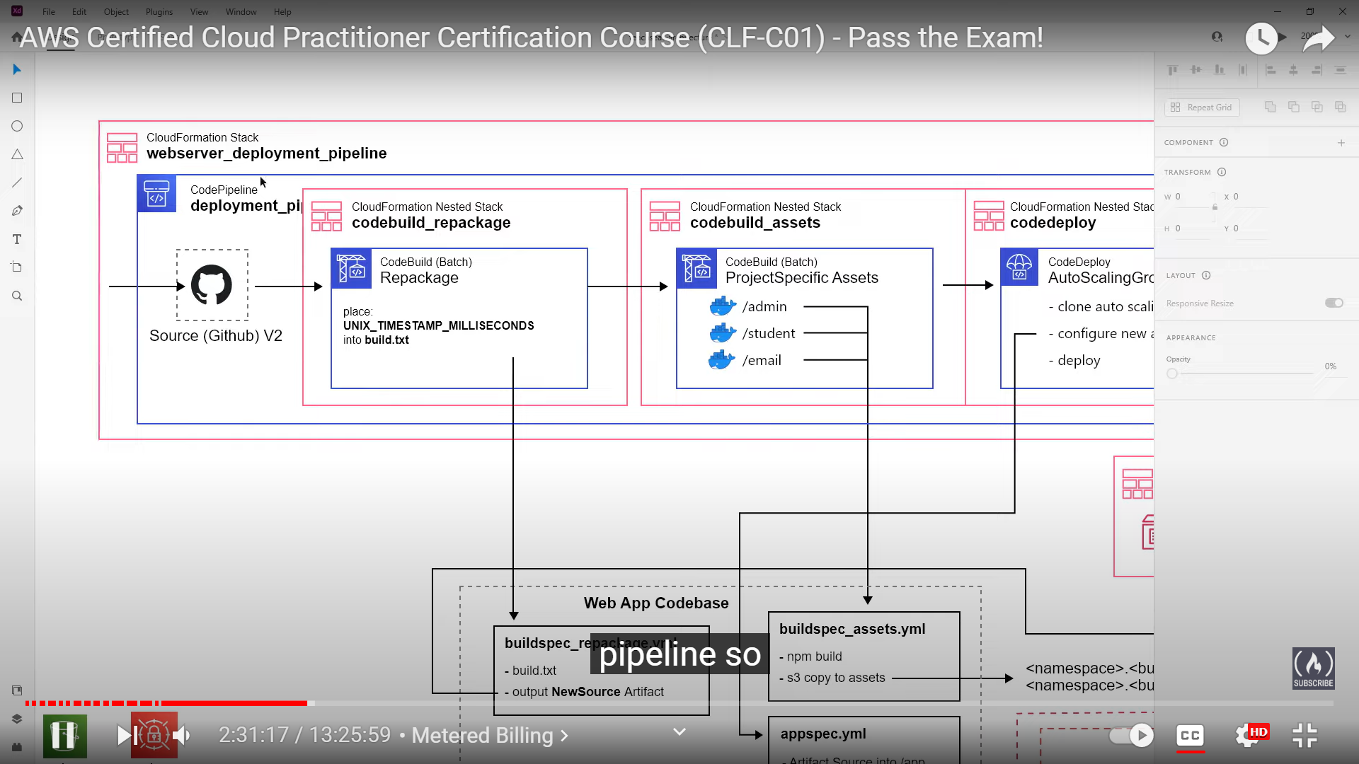

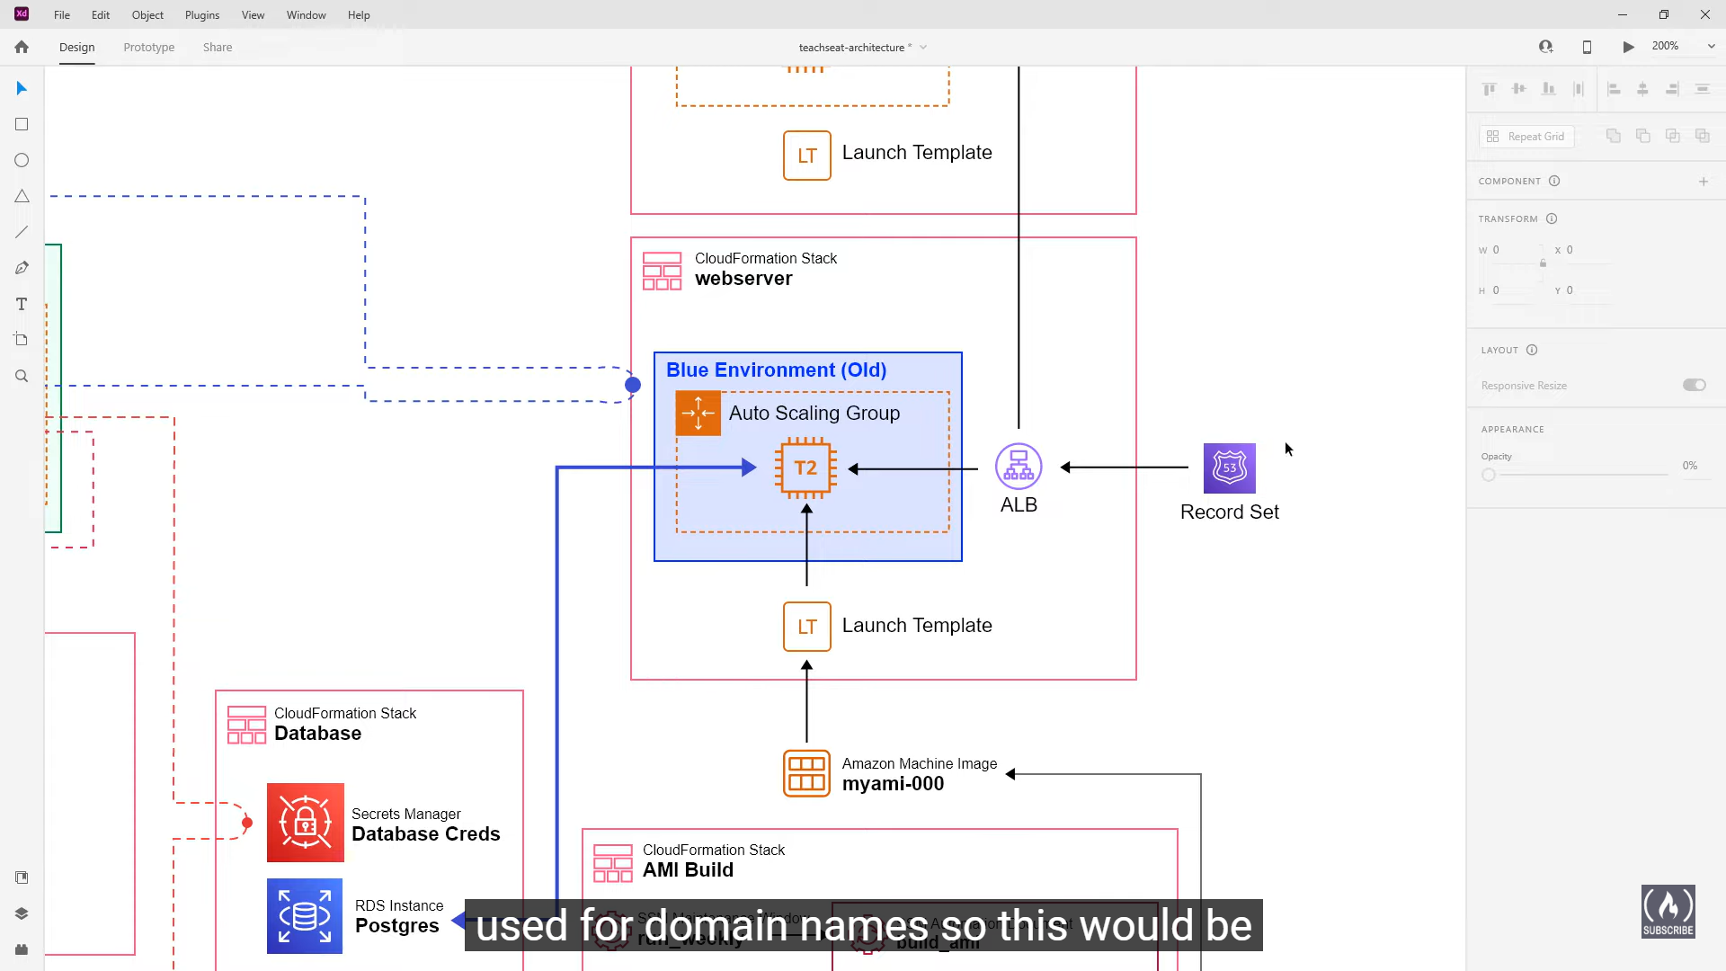

Router 53 routes the traffic to our application from internet

ALB – Application Load Balancer

Have different EC2 instances in different availability zone to make them highly available

Launch template – What is the shape of the instance type, what is its family and what should it be?

Amazon Machine Image (AMI) – Machine image that we are using in our EC2 instance, it can be custom build

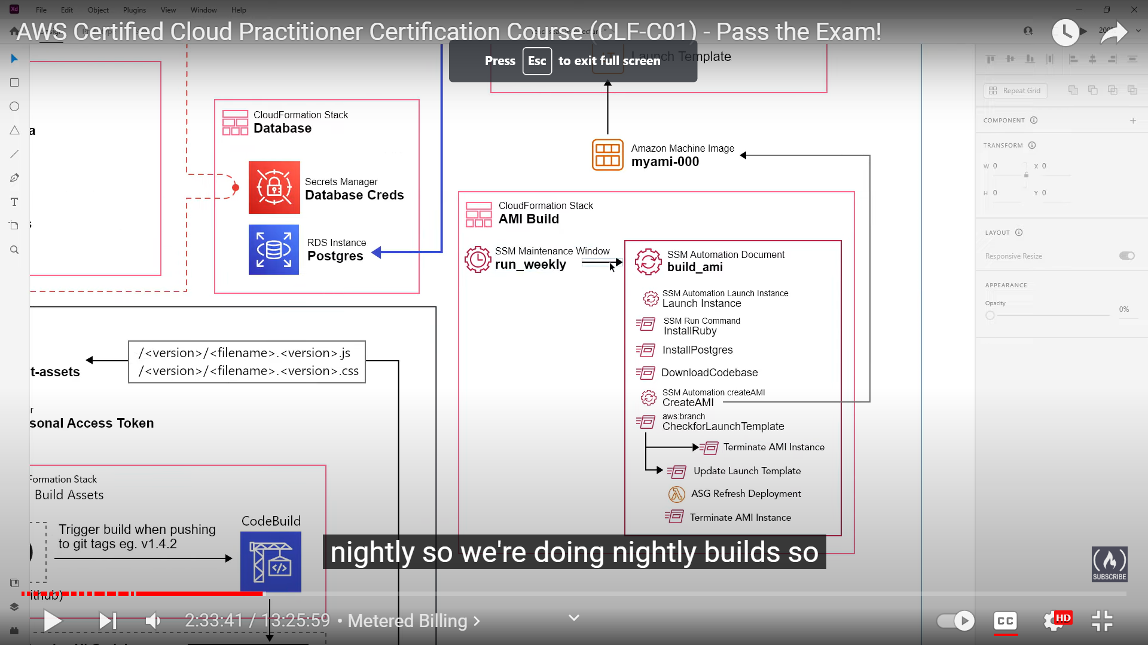

**S3**

Serverless

Highly Available

Replicate in multiple AZ (Availability Zone) or DataCenters in a Region

